UNDERGRADUATE THIRD YEAR ASSIGNMENT
Department of Mechanical Engineering
NED University of Engineering and Technology



LabView Experiments

Group Number: ___________ Batch: 2021 – 2025

Group Member Names:

Syed Shayan Ahmed ME-21008
Syed Muzammil Ahmed ME-21009
Muhammad Ammar Siddiqui ME-21012
Ahsan Iqbal ME-21013

Approved by
……………………………………………………………………………………………...
Dr. Faizan Shirazi
Course Coordinator

© NED University of Engineering & Technology. All Rights Reserved – [April 2024]

Table of contents
Lab session 21 3
Lab session 22 4
Lab session 23 8
Lab session 24 11
Lab session 25 12
Lab session 26 13
Lab session 27 15
Lab session 28 18

Lab session 21
Objective: Introduction to LabVIEW software.
Block Diagram:
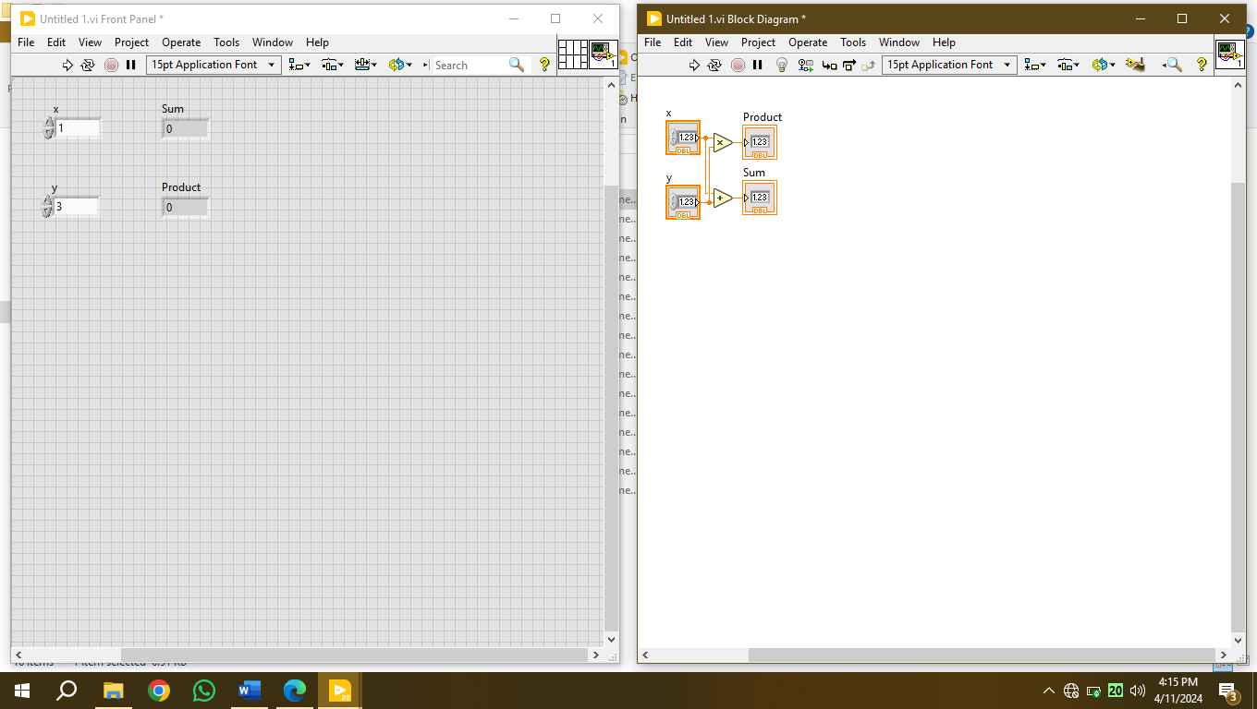
Front Panel:

Lab session 22
Objective: Use LabVIEW software to create subVI, and use it in another VI.
SubVI Block Diagram: 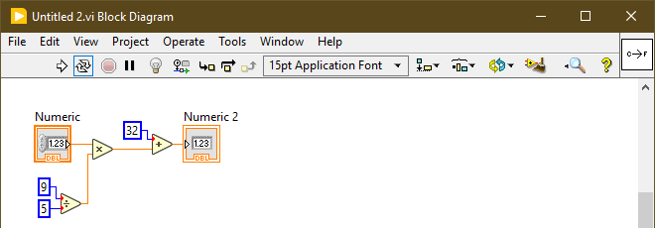
SubVI Front Panel:
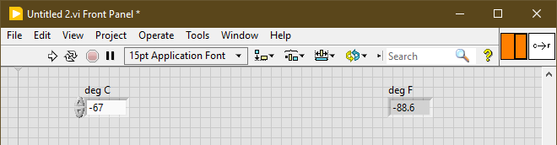
SubVI Icon Editor: 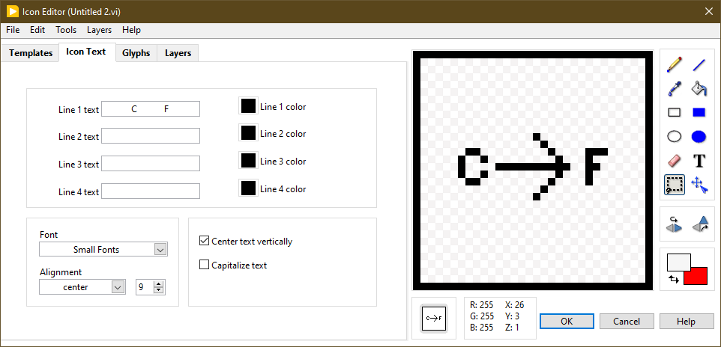

Main Block Diagram:
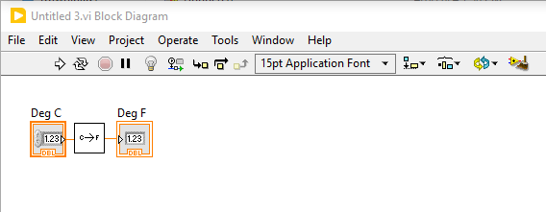
Main Front Panel:
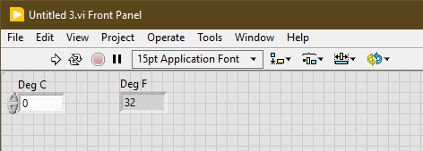

Objective: Use the VI built to calculate square root and convert it into subVI using LabVIEW.
SubVI Block Diagram:
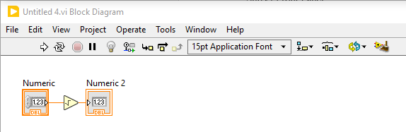
SubVI Front Panel:
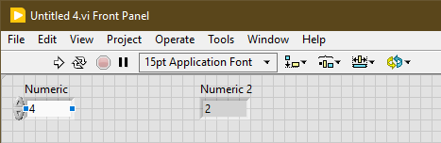
SubVI Icon Editor:
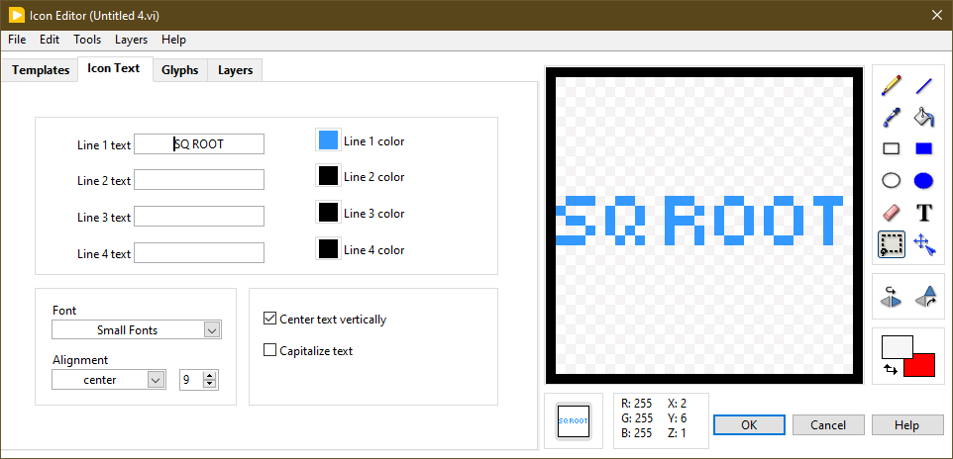
Main Block Diagram:
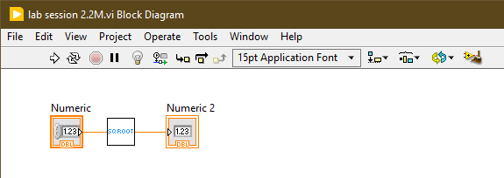
Main Front Panel:
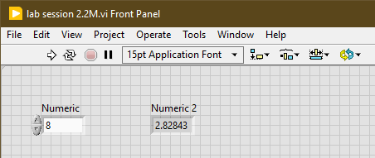

Lab session 23
Objective: Build a VI to convert Rupees to Dollars. Take input from the user by using control.
Block Diagram:
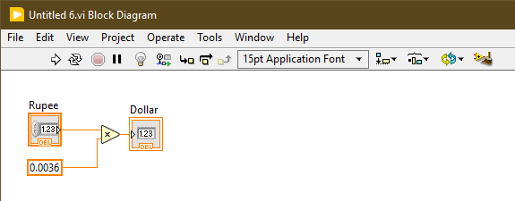
Front Panel:
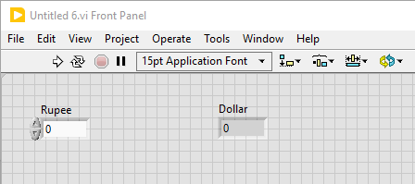

Objective: Solve the given equation 𝒙 𝟐 − 𝟗𝒙 + 𝟐𝟎 = 𝟎 by using quadratic formula
Block Diagram:
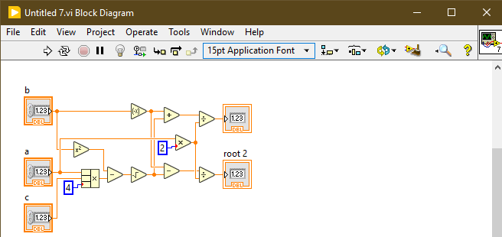
Front Panel:
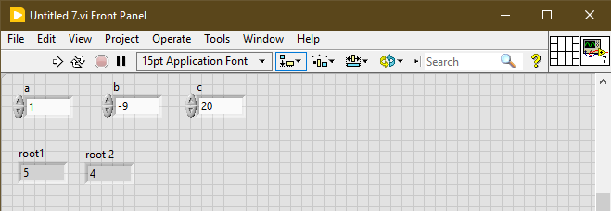

Objective: Verify De Morgan’s laws
Block Diagram:
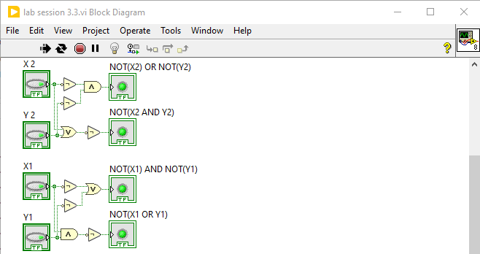
Front Panel:
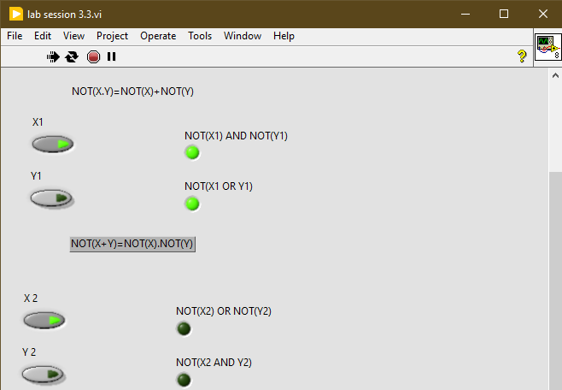

Lab session 24
Objective:
• Use LabVIEW software to learn how loops are designed and work.
• To create a VI for the Multiplication of a random number with 10 and displaying the result continuously, until it is stopped.
Block Diagram:
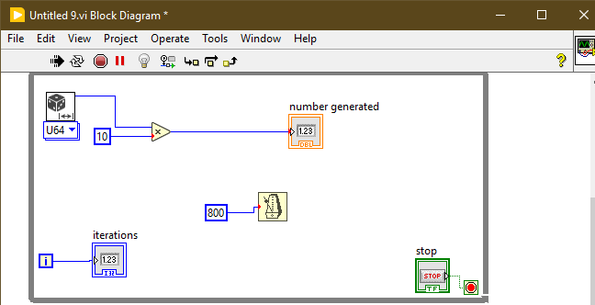
Front Panel:
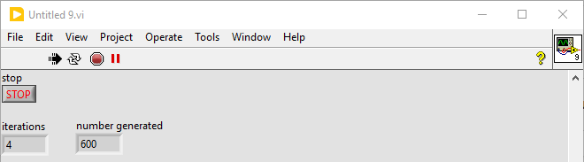

Lab session 25
Objective: Use LabVIEW software to generate random numbers and multiply it with 10.
- If the answer is in between 4 and 6, then program should automatically abort.
- Also introduce a delay of 500 ms after each iteration and display the number of iterations that it took till the condition is met.
- As soon as the condition is met, a dialogue box should appear indicating that your required instance has occurred.
Block Diagram:
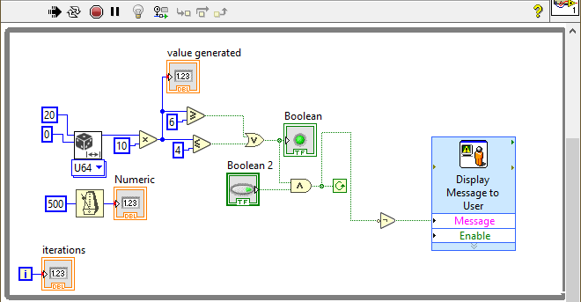
Front Panel:
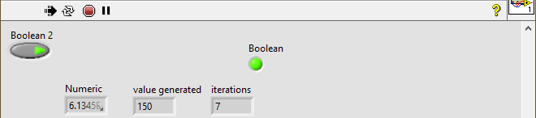
Dialog box message:
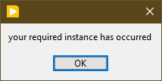

Lab session 26
Objective: Use LabVIEW software to design for loops and observe their working.
Block Diagram:
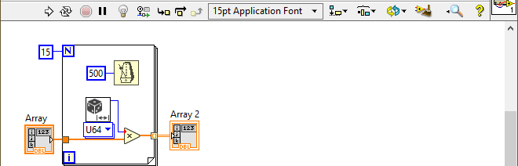
Front Panel:
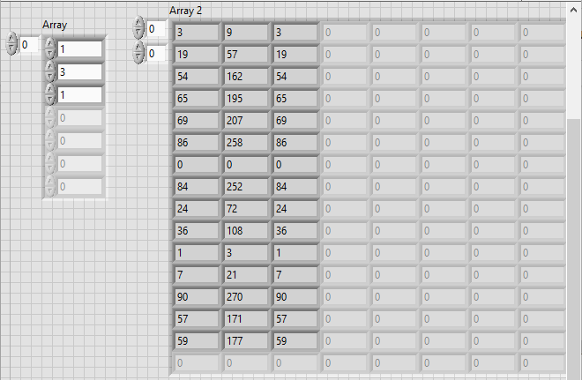

Objective: Add 5 repeatedly in a number and display result in the form of an array after ten iterations.
Block Diagram:
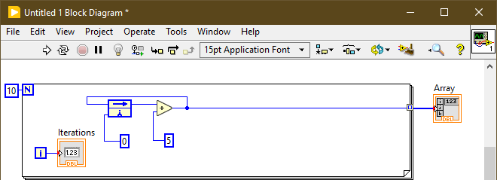
Front Panel:
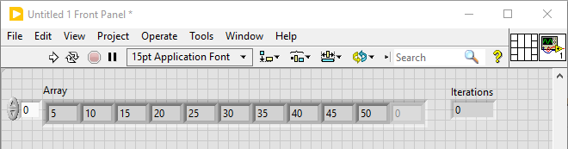

Lab session 27
Objective: Use LabVIEW software to design different functionalities of arrays
Block Diagram:
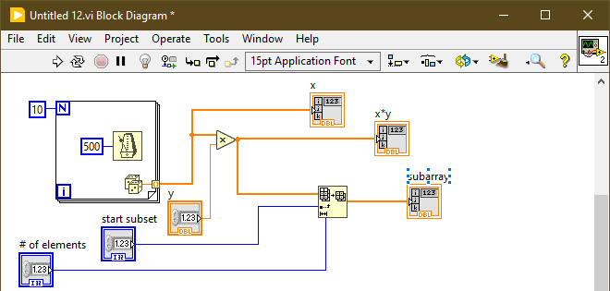
Front Panel:
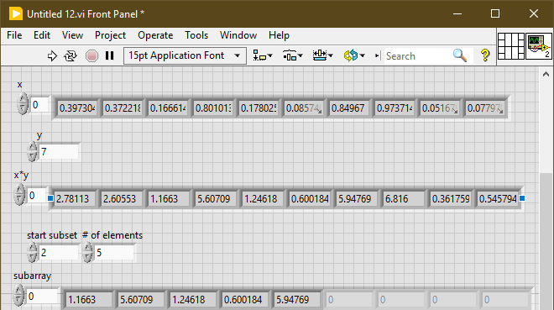

Objective: Create a two-dimensional array of the order 5x5
Block Diagram:
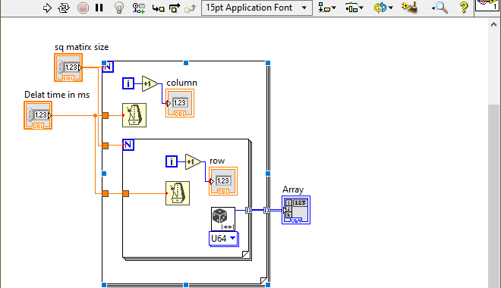
Front Panel:
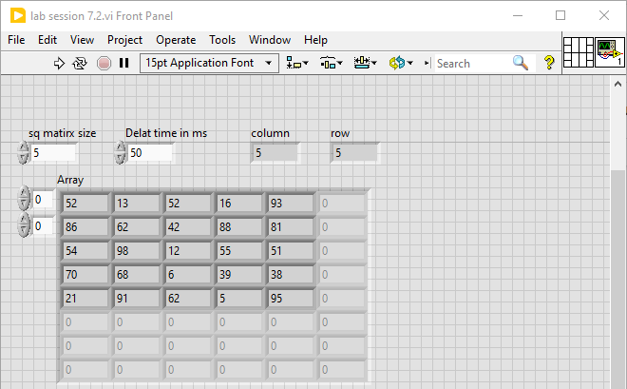
Objective: Verify that integral of constant is a ramp and integral of ramp is a square. Display the two results in separate arrays.
Block Diagram:
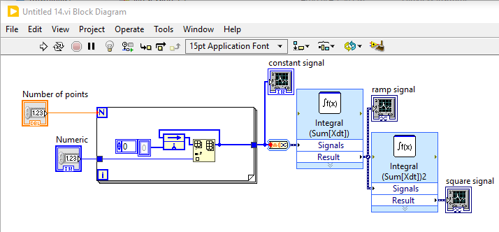
Front Panel:
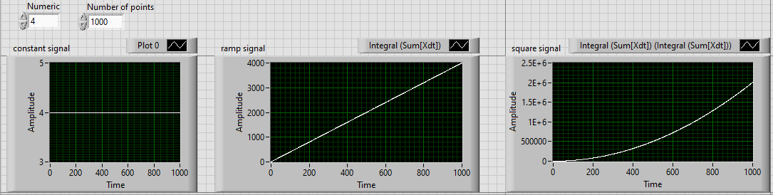

Lab session 28
Objective: Use LabVIEW software to display quantities on waveform charts and waveform graphs.
Block Diagram:
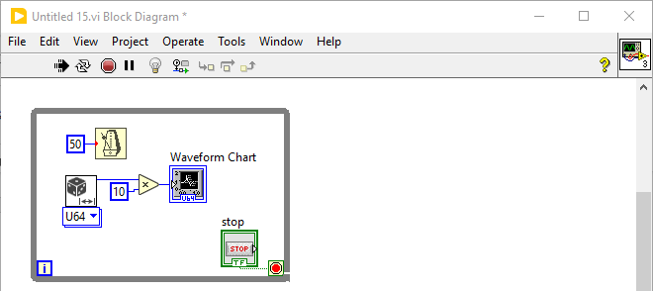
Front Panel:
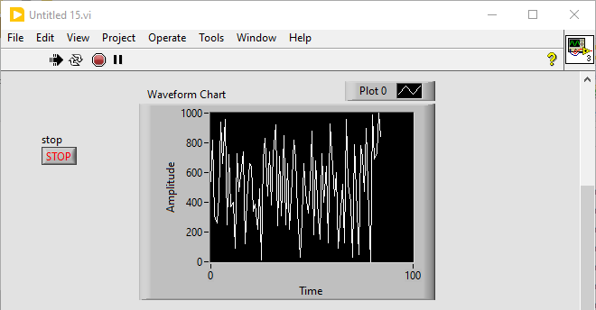
Objective: Generate a sine wave and plot it on a wave chart form. Also double the amplitude of the generated sine wave and plot the two sine waves on the same waveform graph.
Block Diagram:
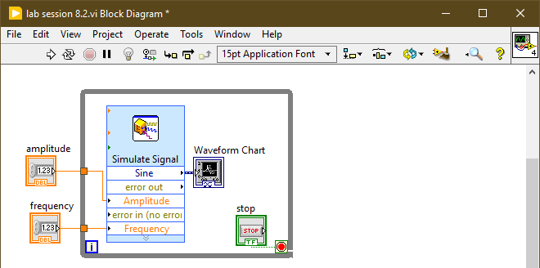
Front Panel:
